Name: Nishant Belwal

Sap ID : 500075268

Roll No : R177219123

Batch: AIML – B4

Experiment-4 (HUB & Switch)

Aim : to study basic of HUB and Switch

**HUB :**

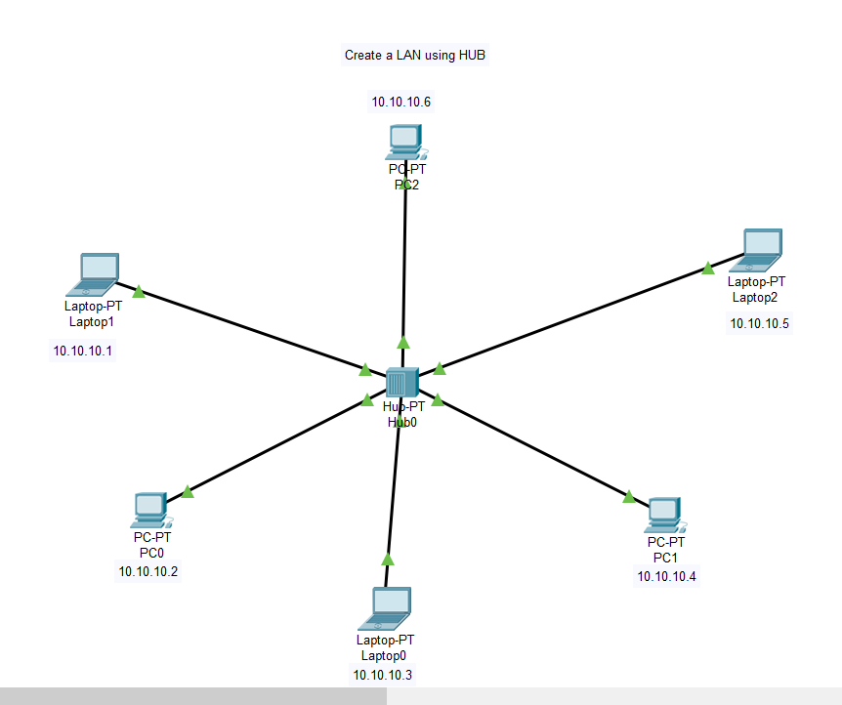

Message is send from Laptop1 to Laptop0

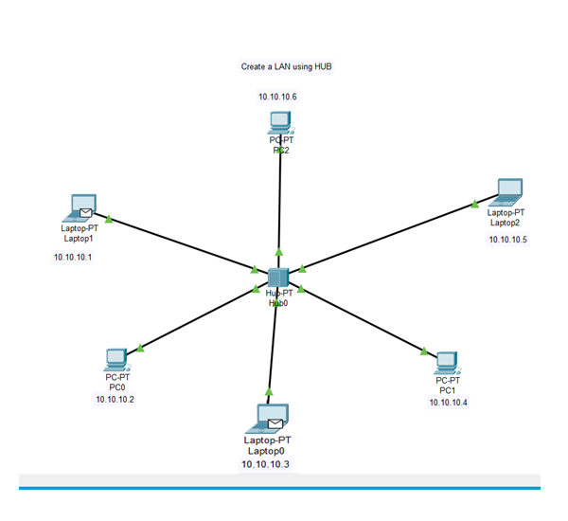

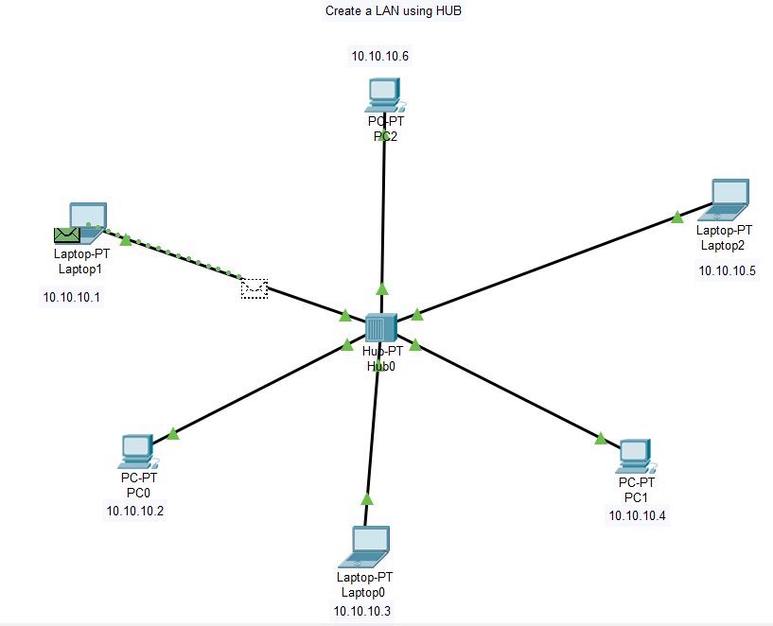

Message is broadcasted to all the devices in the LAN

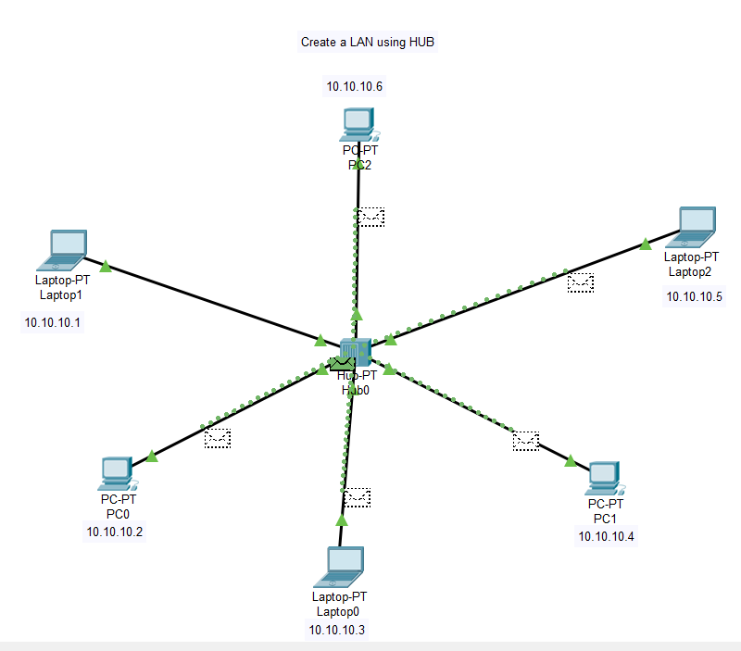

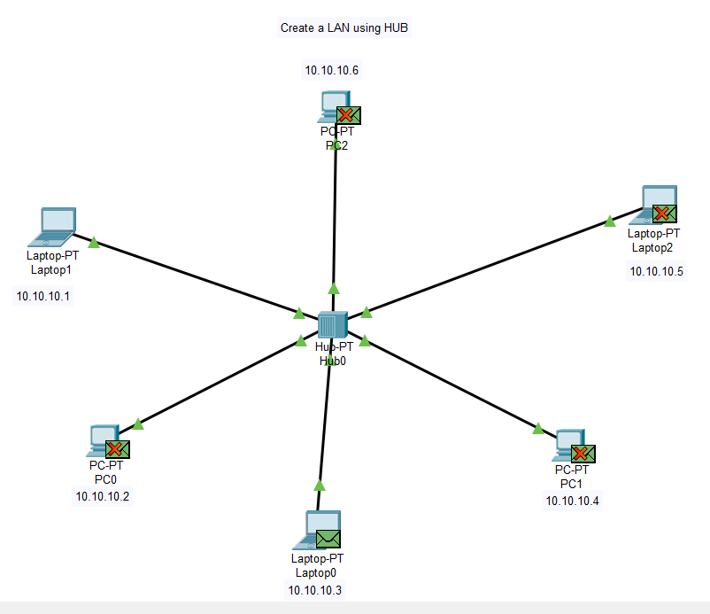

**Switch :**

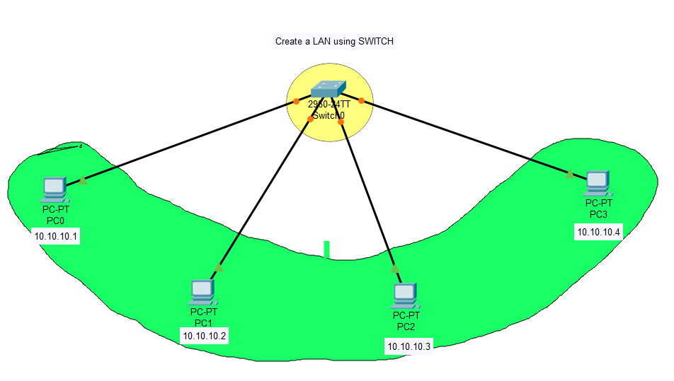

Message is sent from PC0 to PC2

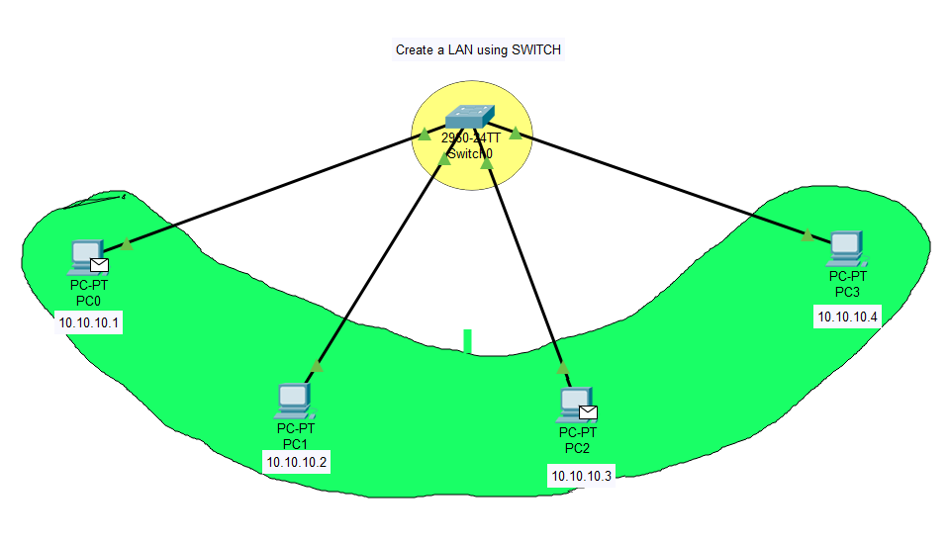

Message is sent by PC0

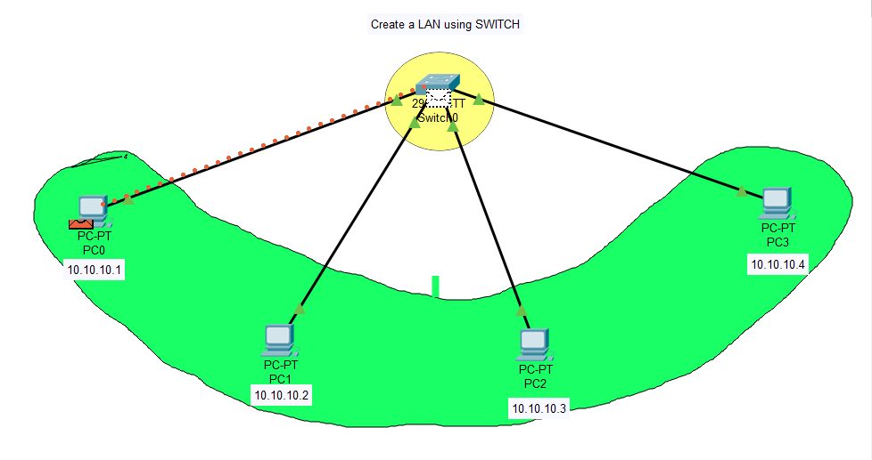

Message is received by PC2

